GUIDE FOR ONLINE PARTICIPATION
Lerøy Seafood Group ASA will hold its annual general meeting on 28 May 2024 at 10:00 am CET as digital meeting, where you get the opportunity to online with your PC, phone or tablet. Below is a description of how to participate online.

By participating online, shareholders will receive a live webcast from the general meeting, the opportunity to ask written questions, and vote on each of the items. Secure identification of shareholders is done by using the unique reference number and PIN code assigned to each shareholder by the Norwegian Central Securities Depository (Euronext VPS) in relation to this General Meeting.

No registration is required to participate online, but shareholders must be logged in before the general meeting starts. Log ins after meeting has started will receive access, but with no voting rights.
Shareholder who do not find their reference number and PIN code for access, or have other technical questions is welcome to call DNB Registrars Department on phone + 47 23 26 80 20 (between 08:00-15:30)
HOW TO ACCESS THE ONLINE GENERAL MEETING
To be able to participate online, you must go to the following website: https://dnb.lumiagm.com
either on your smartphone, tablet or PC. All major known browsers, such as Chrome, Safari, Edge, Firefox etc. are supported.
enter Meeting ID: 116-477-678 and click Join:
Alternatively put direct link in your browser https://dnb.lumiagm.com/116477678
You must then identify yourself with:
a) Ref. number from VPS for the general meeting
b) PIN code from VPS for general meeting

Once you have logged in, you will be taken to the information page for the general meeting. Here you will find information from the company, and how this works technically. Note that you must have internet access throughout the meeting. If you for some reason log off, just log in again following steps above.

HOW TO RECEIVE YOUR REFERENCE NUMBER AND PIN CODE

All shareholders registered in the VPS are assigned their own unique reference and PIN code for use in the General Meeting, available to each shareholder through VPS Investor Services. Access VPS Investor Services, select Corporate Actions, General Meeting. Click on the ISIN and you can see your reference number (Ref.nr.) and PIN code.
All VPS directly registered shareholders have access to investor services either via https://investor.vps.no/garm/auth/login or internet bank. Contact your VPS account operator if you do not have access.
Shareholders who have not selected electronic corporate messages in Investor Services will also receive their reference number and PIN code by post together with the summons from the company (on registration form).
Custodian registered shareholders: Shares held through Custodians (nominee) accounts must exercise their voting rights through their custodian. Please contact your custodian for further information.

HOW TO VOTE
  When items are available for voting, you can vote on all items as quickly as you wish. Items are closed for voting as the general meeting considers them. Items will be pushed to your screen. Click on the vote icon if you click away from the poll.  To vote, press your choice on each of the issues. FOR, AGAINST or ABSTAIN. Once you have cast your vote, you will see that your choice is marked. You also get a choice where you can vote jointly on all items. If you use this option, you can still override the choice on items one by one if desired.  To change your vote, click on another option. You can also choose to cancel. You can change or cancel your vote until the chair of the meeting concludes the voting on the individual items. Your last choice will be valid.  NB: Logged in shareholders who have given a power of attorney will not have the opportunity to vote but can follow and write messages if desired. | 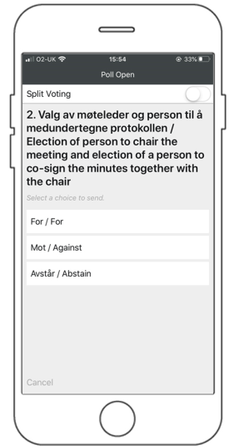

QUESTIONS TO THE CHAIRPERSON
Questions or messages relating to the items on the agenda can be submitted by the shareholder or appointed proxy at any time during the meeting as long as chair of the meeting holds this open.
If you would like to ask a question relating to the items on the agenda, select the messaging icon.
Enter your question in the message box that says "Ask a Question". When you have finished writing your question, click on the submit button.
Questions submitted online will be moderated before going to the chair. This is to avoid repetition of questions as well as removal of inappropriate language.
All shareholders who submit questions will be identified with their full names, but not holding of shares.

